Home page:

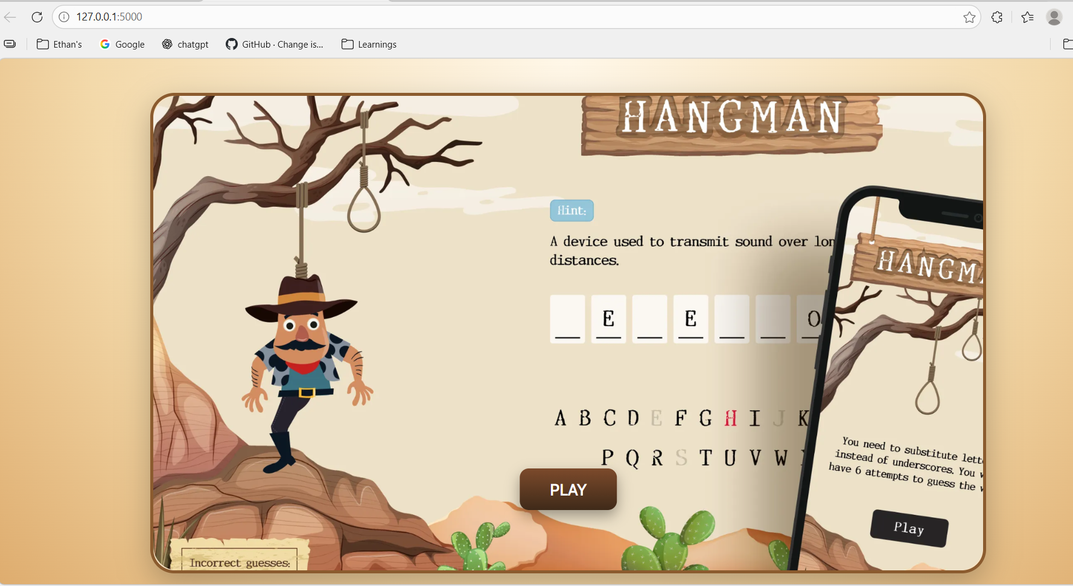

After click on Play button:

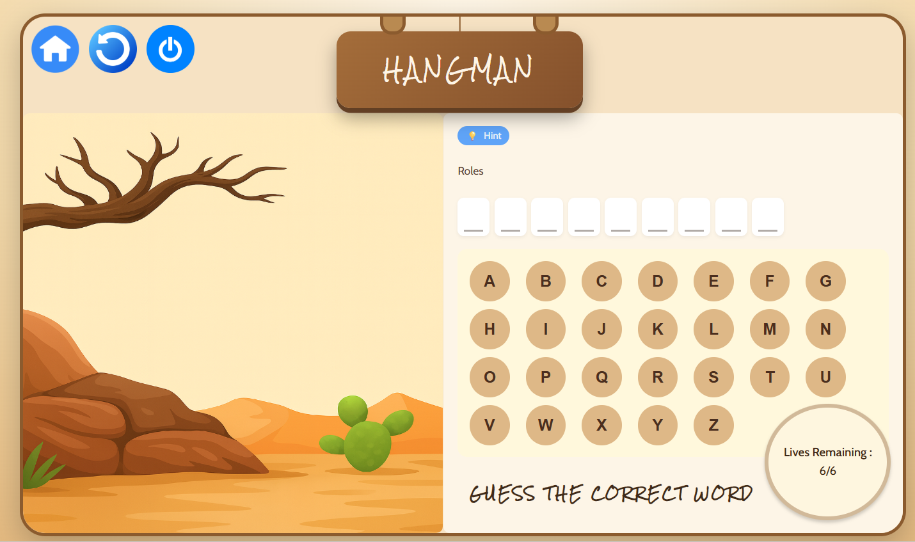

middle of game: Red border for button shows incorrect guess of word, Green border for button shows correct guess of word.In both cases now those buttons are disabled.Lives count and hangman are also updating accordingly.

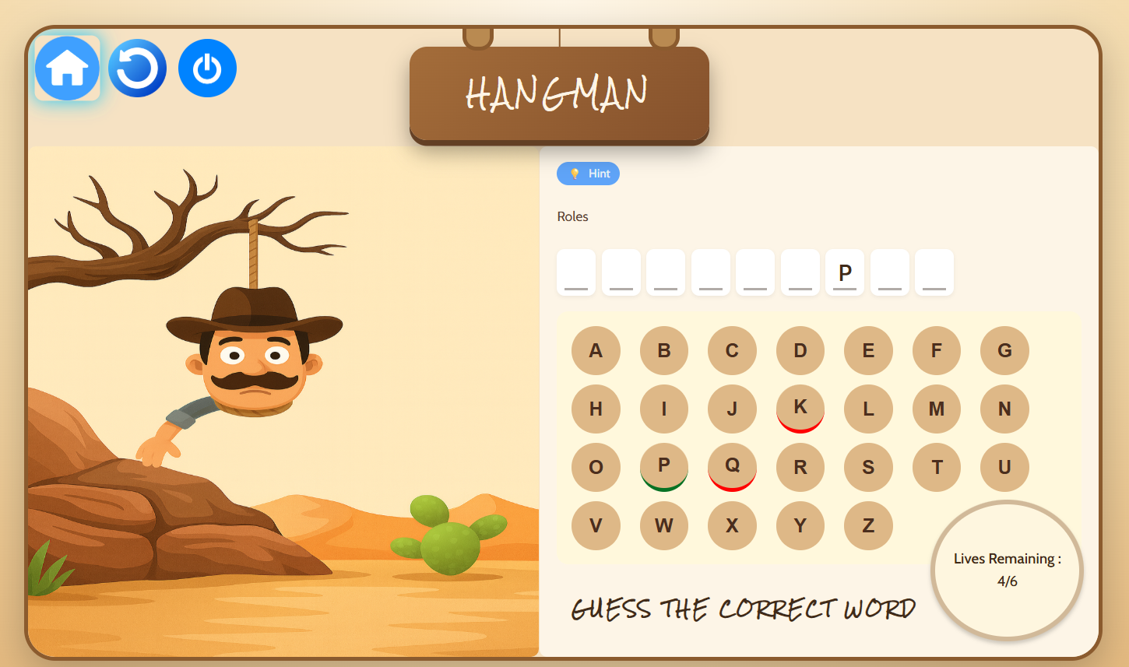

Loss case : Right top side score is printing. At this stage the full sad hangman is displayed with sad music audio.

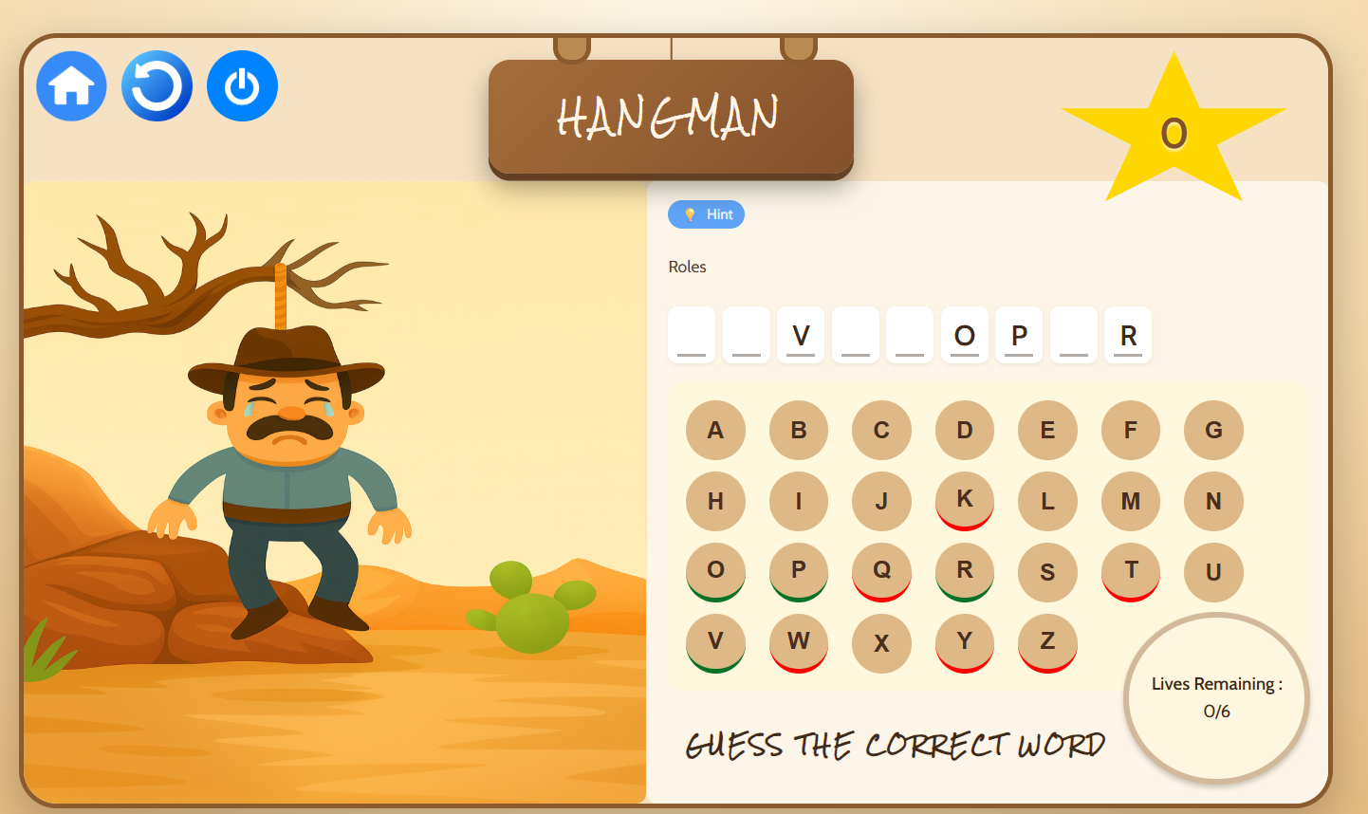

Win case : Right top side score is printing. At this stage the full happy hangman is displayed with victory music audio.

